

# VISVESVARAYA TECHNOLOGICAL UNIVERSITY

## Jnana Sangama, Belagavi-590018

### **S.D.M. COLLEGE OF ENGINEERING AND TECHNOLOGY, DHARWAD-580002**

**(An autonomous Institution affiliated to VTU, Belagavi)**

**DEPARTMENT OF ELECTRICAL AND ELECTRONICS ENGINEERING**

## **MAJOR PROJECT REPORT**

**On**

## “**ELECTRIC CAR AUTOMATION**”

### Submitted By:

#### V BHOOMIKA 2SD19EE059

VIJETH M DURGEKAR 2SD19EE060

RAMESH ARER 2SD20EE402

SHUAIB M MUDENUR 2SD20EE404

## **Under the Guidance of:**

**Prof. T. M. Timsani**

2022-2023

i



# S.D.M. COLLEGE OF ENGINEERING &TECHNOLOGY

# DHARWAD – 580002

**(An Autonomous Institution affiliated to Visvesvaraya Technological University, Belagavi - 590018)**

# Department of Electrical and Electronics Engineering

**CERTIFICATE**

Certified that the project work entitled “**ELECTRIC CAR AUTOMATION”** is an original work carried out by **V BHOOMIKA (2SD19EE059), VIJETH M DURGEKAR (2SD19EE060), RAMESH ARER (2SD20EE402), SHUAIB M MUDENUR (2SD20EE404)** in partial fulfilment for the award of degree of Bachelor of Engineering in **ELECTRICAL AND ELECTRONICS** of **S. D. M. College of Engineering & Technology under the Visvesvaraya Technological University, Belagavi** during the year 2022– 23. The project report has been approved as it satisfies the academic requirements in respect of Project work prescribed for the award of Bachelor of Engineering Degree.

**Signature of the Guide Signature of the HOD Signature of the Principal**

**Name and signature of the examiners:**

|  |  |  |
| --- | --- | --- |
| **Sl. No.** | **Name** | **Signature with date** |
| **1.** |  |  |
| **2.** |  |  |

ii

### **ACKNOWLEDGEMENT:**

We sincerely acknowledge the help received from various persons and sources in collecting data and information in completing the major project phase, satisfactorily.

We thank our parents for their continuous encouragement, motivation and blessing without which any of us would not have reached this stage.

We thank **Dr. K. GOPINATH PRINCIPAL** SDMCET for providing necessary infrastructure for completion of the project.

We take the immense pleasure to thank our head of department **Dr. S. G. ANKALIKI** for permitting us to take on this project.

The great opportunity to express our deep sense of gratitude and affectionate repeat to our guide **PROF. T M TIMSANI** not only for his full support and guidance but also for his valuable suggestions and help at any time, which led to successful completion of the major project.

iii

**ABSTRACT**

Car Automation is one of the important aspects of today’s modern vehicles. This project involves the design and implementation of intelligent car with obstacle avoidance system and Security system.

The objective of this project is to implement an intelligent car.

* Which moves the ability to detect obstacle in its path and change direction to where obstacle is not present without any external influence. The new direction to be taken to avoid collision that has the most distance between the obstacle and the sensor, is determined by the sensor inputs.
* Speed control based on climatic condition.

iv

**CONTENTS**

PAGE NO.

TITLE PAGE i

CERTIFICATE ii

ACKNOWLEDGEMENT iii

ABSTRACT iv

**CHAPTER 1**: INTRODUCTION 1

**CHAPTER 2**: OBJECTIVES 2

**CHAPTER 3**: LITERATURE SURVEY 3

**CHAPTER 4**: METHODOLOGY 5

4.1 BLOCK DIAGRAM 6

4.2 COMPONENT DETAILS 7

4.3 COST ESTIMATION 13

4.4 FLOWCHART 14

**CHAPTER 5:** CODE 15

**CHAPTER 6**:

6.1 ADVANTAGES 19

6.2 APPLICATIONS 19

**CHAPTER 7**: RESULT 20

**CHAPTER 8**: REFERENCE 21

CONCLUSION 24

REFERENCES 25

# CHAPTER 1: INTRODUCTION

* Car Automation is one of the important aspects of today’s modern vehicles. This project involves the design and implementation of intelligent car with obstacle avoidance system and Security system.
* Motion being a vital characteristic of vehicle in obstacle avoidance and path recognition has a major impact on how people react and perceive an autonomous system.
* Enabling safe driving conditions through controlling speed on the basis temperature and humidity of the outside climate/weather.
* The robot car should have the capacity to detect obstacles in its path based on a predetermined threshold distance.
* After detection of an obstacle, the robot should be able to change its direction to a relatively open path by making an autonomous decision.
* The robot car should be able to measure distance between itself and an obstacle in real time.

# CHAPTER 2: OBJECTIVES

The main objective of our project is to implement an intelligent car,

* Which moves the ability to detect obstacle in its path and change direction to where obstacle is not present without any external influence.
* Speed control based on climatic condition.

# CHAPTER 3: LITERATURE SURVEY

1. Development Of An Arduino-based Obstacle Avoidance Robotic System For An Unmanned Vehicle.

By: Anthony C. Mmonyi, Samuel Olushola Dada.

1. Obstacle detection and avoidance by a mobile robot. National Institute of Technology, Rourkela. B.Sc. thesis. pp. 1-9.

By: J. Seja and M. Banshidhar.

1. "Temperature and humidity monitoring and control system based on Arduino and Sim900A GSM Shield" by Jay Sipani, Riki Patel ; Chandubhai S Patel Institute of Technology, Changa.

* Vol 5, Issue 11, 2017.

1. Automatic Vehicle Speed Control System In a restricted Zone

By: Sathiskumar S, Navean G V, Hari Prakash R, Vishnu Praveen S

# CHAPTER 4: METHODOLOGY

The car uses the Ultrasonic sensor to measure the distance in front of it then it moves. As the distance reduces, the car interprets it as the presence of an obstacle. As soon as the sensor detects the obstacle, it stops and moves back a few cm then looks left and right before moving to a free path.

The humidity sensing car speed limiter is a system device that is installed and integrated in a vehicle to determine the humidity condition and automatically limit the speed of the vehicle according to the humidity condition level. It coincides with the automatic brake system that decreases the speed of vehicle if speed limit is exceeds. The Arduino attached in the control box processes the data and produces a response which is divided into Dry area, moderate area, Foggy area.

**BLOCK DIAGRAM:**

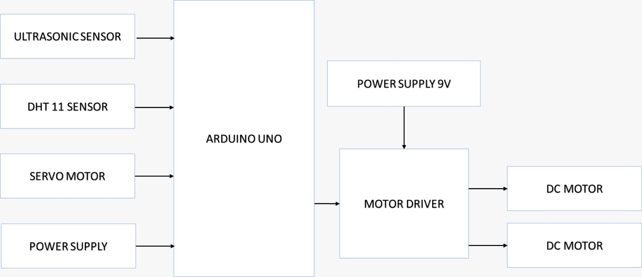

**Fig 4.1 car automation block diagram**

**COMPONENTS:**

**Ultrasonic Sensor:**

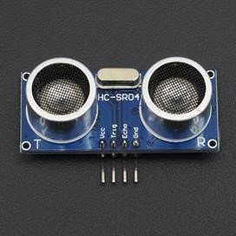

Fig 4.2 Ultrasonic sensor

(The HC-SR04 Ultrasonic Distance Sensor is a sensor used for detecting the distance to an object using sonar). An Ultrasonic sensor is a device that can measure the distance to an object by using sound waves. It measures distance by sending out a sound wave at a specific frequency and listening for that sound wave to bounce back. By recording the elapsed time between the sound wave being generated and the sound wave bouncing back, it is possible to calculate the distance between the sonar sensor and the object. It is important to understand that some objects might not be detected by ultrasonic sensors. This is because some objects are shaped or positioned in such a way that the sound wave bounces off the object, but are deflected away from the Ultrasonic sensor. It is also possible for the object to be too small to reflect enough of the sound wave back to the sensor to be detected. Other objects can absorb the sound wave all together (cloth, carpeting, etc.), which means that there is no way for the sensor to detect them accurately.

Specifications are:

1. Operating voltage : 5V DC
2. Operating current : 15mA
3. Detection range : 2cm to 400cm
4. Frequency : 40KHz
5. Trigger pulse width: 10μs
6. Echo pulse width: 100μs to 25ms
7. Dimensions: 45mm x 20mm x 15mm

**Arduino UNO:**

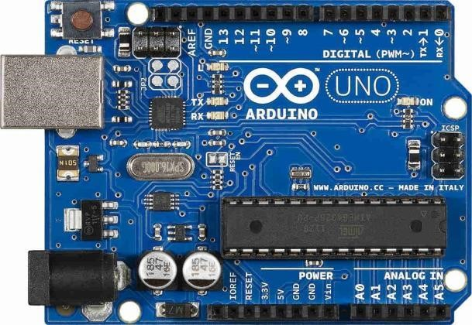

Fig 4.3 Arduino Uno

The Arduino UNO is an open-source micro-controller board based on the Microchip ATmega328P micro-controller and developed by Arduino cc. The board is equipped with sets of digital and analog input/output pins. Atmega 328 micro-controller acts as a processor for the Arduino board. Nearly it consists of 28 pins. From these 28 pins, the inputs can be controlled by transmitting and receiving the inputs to the external device. It also consists of pulse width modulation (PWM). These PWM are used to transmit the entire signal in a pulse modulation. Input power supply such as Vcc and ground are used. These IC mainly consists of analog and digital inputs. These analog and digital inputs are used for the process of certain applications. The working of Arduino micro-controller is where the proper connection is made checking all the input ports as well as the power supply connection. The output of the pins can be connected with the external devices according to their applications. The program to be executed for the applications can be done by using Arduino software. Then after, these programs can be uploaded through the Arduino micro-controller by using the power jack cable. The purpose of reset button is to reset the program which means the previous programs are deleted and we can use the Arduino for the other application purposes. These Arduino ATMEGA-328 micro-controllers can be used for ‘n’ number of applications. These Arduino micro-controllers are widely used in automation industries for controlling the process and to work the system in an automation mode.

**MOTOR:**

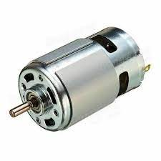

Fig 4.4 Motor

An electric motor is an electrical machine that converts electrical energy into mechanical energy. Specifications are:

1. Operating Voltage: 12V.
2. Rated Speed : 200RPM.
3. Rated Torque: 1.5kg-cm.
4. Stall Torque: 5.4kg-cm.
5. Load Current : 0.3A.
6. No Load Current : 0.06A.

**9V BATTERY:**

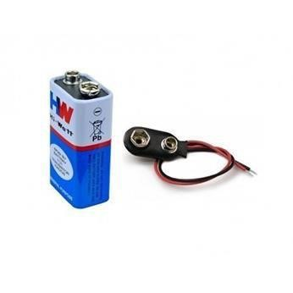

Fig 4.5 9V Battery

The battery is used to provide power supply to the system for its operation. For our system we use a power supply of 9v.

**MOTOR DRIVE:**

The L298N driver is an integrated circuit (IC) that provides a convenient way to control and drive DC motors and stepper motors. It consists of two H-bridge circuits. Each H-bridge is composed of four transistors (usually MOSFETs) arranged in a specific configuration. The H-bridge allows the current to flow in either direction through the motor, enabling control of both the motor's direction of rotation and its speed. It has four control inputs: IN1, IN2, IN3, and IN4. These inputs determine the motor direction and enable/disable the motor outputs. By controlling the states of these inputs, the motor's behaviour can be controlled. i.e., by setting the corresponding control inputs of the L298N driver. For example, if set IN1 to HIGH and IN2 to LOW, the motor connected to the first H-bridge will rotate in one direction. If reversed the states of IN1 and IN2, the motor will rotate in the opposite direction. Speed control of the motors is achieved by using pulse width modulation (PWM) signals. By applying a PWM signal to the enable pins, ENA and ENB, controlling the average voltage applied to the motor, thus controlling its speed. A higher PWM duty cycle will result in a higher motor speed, while a lower duty cycle will reduce the speed. It requires two power supply connections, the voltage required by the motors. The logic power supply (Vss) powers the control circuitry of the L298N driver and is typically connected to 5V. It has built-in current sensing capabilities. By monitoring the voltage across the sense resistors connected to the output pins, we can measure the current flowing through the motors.

Specifications are:

1. Chip: L298N
2. Logical voltage: 5V
3. Drive voltage: 5V-35V
4. Logical current: 0mA-36mA
5. Drive current: 2A (MAX single bridge)
6. Storage temperature: -20 to +135
7. Max power: 25W
8. Weight: 30g
9. Size: 43 x 43 x 27mm

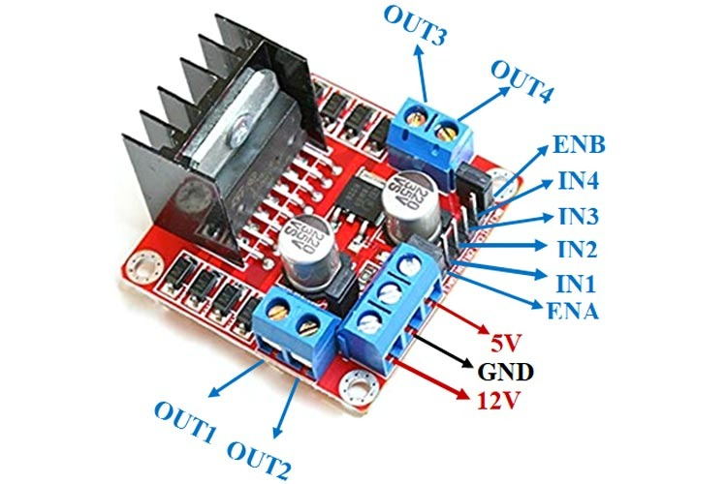

Fig 4.6 Motor drive

**SERVOMOTOR:**

A servomotor is a rotary actuator or linear actuator that allows for precise control of angular or linear position, velocity and acceleration and it is a type of motor that is commonly used in robotics and automation. It is a closed-loop system that uses feedback to control the position, speed, and torque of the motor. The servo motor consists of a motor, a control circuit, and a feedback mechanism, usually in the form of a potentiometer. The control circuit receives a signal from a microcontroller or other device and adjusts the position of the motor based on the feedback from the potentiometer. Allows the servo motor to rotate to a specific angle and hold that position, making it ideal for applications that require precise control, such as robotic arms, drones, and RC vehicles.

Specifications are:

1. Operating voltage: 4.8V to 6V DC
2. Operating current: 10mA(ideally), 100-250mA(during movement)
3. Speed : 0.15 sec/60 degree
4. Torque : 4.8V
5. Power : 0.4 watt

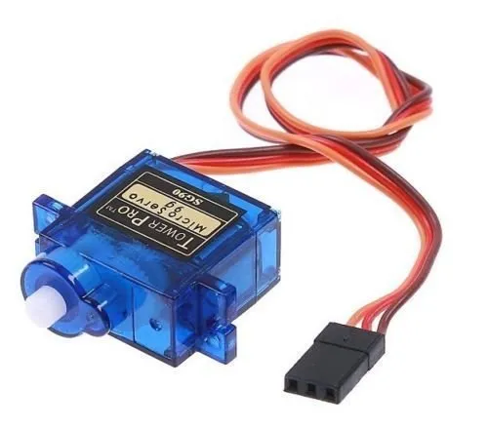

Fig 4.7 Servomotor

**DHT11 sensor:**



Fig 4.8 DHT11 sensor

The above sensor is a digital temperature and humidity sensor that can be used in various applications. The DHT11 sensor works by using a thermistor to measure the temperature and a capacitive humidity sensor to measure the relative humidity. The sensor has a built-in microcontroller that converts the analog signals from the thermistor and humidity sensor into digital signals that can be read by a microcontroller. The sensor communicates with the microcontroller using a single-wire interface and sends data in the form of a 40-bit digital signal. The first 16 bits of the signal represent the relative humidity, the next 16 bits represent the temperature, and the last 8 bits are a checksum to ensure data accuracy. The microcontroller can then use this data to perform various actions, such as controlling a fan or sending alerts based on temperature and humidity readings. The sensor has a single-wire interface and can be connected to microcontrollers like Arduino, Raspberry Pi, and others. It is commonly used in weather stations, HVAC systems, and other projects that require temperature and humidity monitoring.

Specifications are:

1. Operating voltage: 3.3V to 5V dc
2. Temperature range: 0°C to 50°C with ±2°C accuracy
3. Humidity range: 20% to 80% humidity reading with ±5% RH accuracy
4. Dimensions: 12mm x 15.5mm x 5.5mm
5. Data : Outputs both Temperature and Humidity through serial Data
6. Ground : Connected to the ground of the circuit

**COST ESTIMATION:**

|  |  |  |  |
| --- | --- | --- | --- |
| **SL NO** | **Component Name** | **Quantity** | **Cost** |
| 1. | ARDUINO UNO R3 | 2 | 1800 |
| 2. | HCSR-04 (ultrasonic sensor) | 3 | 240 |
| 3. | GPS Module | 1 | 500 |
| 4. | GSM Module | 1 | 1300 |
| 5. | Bread Boards | 2 | 200 |
| 6. | Vibration motor | 1 | 100 |
| 7. | Buzzer | 3 | 150 |
| 8. | Battery 5V | 5 | 200 |
| 9. | PVC pipe | 1.5m | 150 |
| 10. | PCB | 2 | 100 |
| 11. | miscellaneous | - | 1000 |
|  | TOTAL  COST |  | **Rs.5740** |

**FLOW CHART:**

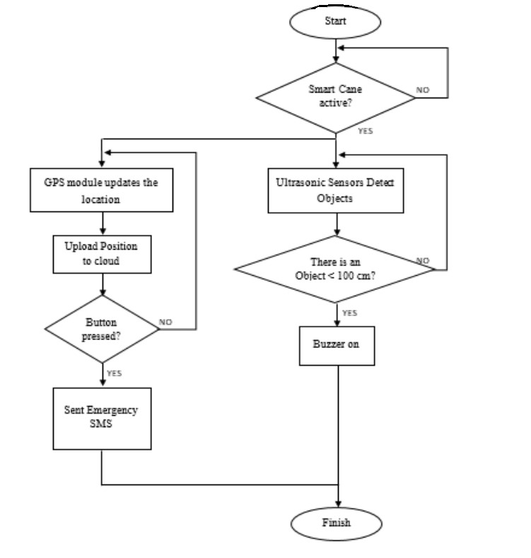

Fig 4.9 flow chart of blind stick

# CHAPTER 5: CODE

int duration=0;

long distance=0;

int firstduration=0;

long firstdistance=0;

int secondduration=0;

long seconddistance=0;

// motor drive

// Motor A connections

int enA = 3;

int in1 = 4;

int in2 = 5;

// Motor B connections

int enB = 9;

int in3 = 10;

int in4 = 11;

#include <Servo.h>

Servo myservo;

int pos = 0;

#include <dht.h>

dht DHT;

#define DHT11_PIN 12

int x;

int y;

int chk;

float hum; //Stores humidity value

float temp; //Stores temperature value

void setup()

{

// Set all the motor control pins to outputs

pinMode(enA, OUTPUT);

pinMode(enB, OUTPUT);

pinMode(in1, OUTPUT);

pinMode(in2, OUTPUT);

pinMode(in3, OUTPUT);

pinMode(in4, OUTPUT);

myservo.attach(2);

Serial.begin(9600);

digitalWrite(in1, LOW);

digitalWrite(in2, LOW);

digitalWrite(in3, LOW);

digitalWrite(in4, LOW);

}

void loop()

{

analogWrite(enA, 255);

analogWrite(enB, 255);

digitalWrite(7, HIGH);

delayMicroseconds(10);

digitalWrite(7, LOW);

delayMicroseconds(2);

duration= pulseIn(6,HIGH);

delay(100);

distance=duration*0.034/2;

Serial.println(distance);

if(distance<=20)

{

digitalWrite(in1, LOW);

digitalWrite(in2, LOW);

digitalWrite(in3, LOW);

digitalWrite(in4, LOW);

delay(300);

digitalWrite(in1, LOW);

digitalWrite(in2, HIGH);

digitalWrite(in3, LOW);

digitalWrite(in4, HIGH);

delay(350);

digitalWrite(in1, LOW);

digitalWrite(in2, LOW);

digitalWrite(in3, LOW);

digitalWrite(in4, LOW);

myservo.write(0);

delay(500);

digitalWrite(7, HIGH);

delayMicroseconds(10);

digitalWrite(7, LOW);

delayMicroseconds(2);

firstduration= pulseIn(6,HIGH);

delay(100);

firstdistance=firstduration*0.034/2;

int first = firstdistance;

Serial.println(firstdistance);

myservo.write(90);

delay(500);

myservo.write(180);

delay(500);

digitalWrite(7, HIGH);

delayMicroseconds(10);

digitalWrite(7, LOW);

delayMicroseconds(2);

secondduration= pulseIn(6,HIGH);

delay(100);

seconddistance=secondduration*0.034/2;

int second = seconddistance;

Serial.println(seconddistance);

myservo.write(90);

delay(500);

if(first < second )

{

digitalWrite(in1, LOW);

digitalWrite(in2, HIGH);

digitalWrite(in3, HIGH);

digitalWrite(in4, LOW);

delay(500);

}

else if(first > second )

{

digitalWrite(in1, HIGH);

digitalWrite(in2, LOW);

digitalWrite(in3, LOW);

digitalWrite(in4, HIGH);

delay(500);

}

}

else

{

int chk = DHT.read11(DHT11_PIN);

Serial.print("Temperature = ");

Serial.println(DHT.temperature);

Serial.print("Humidity = ");

Serial.println(DHT.humidity);

hum = DHT.humidity;

temp = DHT.temperature;

y=hum/10;

x=10-y;

digitalWrite(in1, HIGH);

digitalWrite(in2, LOW);

digitalWrite(in3, HIGH);

digitalWrite(in4, LOW);

analogWrite(enA, y);

analogWrite(enB, y);

}

}

# CHAPTER 6:

# 6.1 ADVANTAGES

1. Prevents minor as well as major accidents.
2. It can be used as a movable surveillance system.
3. The vehicle will move only with designed speeds corresponding to the zones.
4. It does not require man power.
   1. **APPLICATIONS**
5. Can be added as an additional application in heavy duty vehicle (Truck etc).
6. Can be used in Military vehicles.
7. They can also be used in dangerous environments, where human penetration could be fatal.

# CHAPTER 7: RESULTS

**CHAPTER 8: REFERENCE**

1. “Embedded systems and autonomous car” By. G. Dnyaneshwar, M. Harish
2. “Arduino Based Obstacle Avoidance Robot Car” by Michael Akwe Ari
3. Design of an Obstacle-avoiding Robot Car Based on Arduino Microcontroller By: Mugahed Ghaleb
4. Development Of An Arduino-based Obstacle Avoidance Robotic System For An Unmanned Vehicle By: Anthony C. Mmonyi, Samuel Olushola Dada
5. Obstacle detection and avoidance by a mobile robot. National Institute of Technology, Rourkela. B.Sc. By: J. Seja and M. Banshidhar.
6. "Temperature and humidity monitoring and control system based on Arduino and Sim900A GSM Shield" by Jay Sipani, Riki Patel ; Chandubhai S Patel Institute of Technology, Changa - Vol 5, Issue 11, 2017
7. <https://create.arduino.cc/projecthub/adam/obstacle-avoiding-car-a192d9?ref=tag&ref_id=car&offset=4>
8. <https://create.arduino.cc/projecthub/Ashraf_Nabil/tracking-and-controlling-your-car-remotely-using-arduino-and-cc10ed?ref=tag&ref_id=car&offset=19>
9. <https://www.researchgate.net/publication/329042229>
10. <https://link.springer.com/chapter/10.1007/978-981-15-0058-9_48>

**CONCLUSION**

In this project a simple prototype of a automatic car is demonstrated. The prototype car can recognize three separate signals – turn left, turn right and stop with great accuracy and take decision accordingly. The prototype can be further improved by including more signals and using ML approach.